Examples: Assembled and Unassembled Sets

| September-20 |

**Document Overview**

**Documentation Goals**

This documentation is intended to provide the user with an example of the ***Assembled and Unassembled Set*** documentation*.*

**Table of Contents**

**Assembled Sets** 2

Overview 2

Example 2

**Unassembled Sets** 3

Overview 3

Example 3

# **Assembled Sets**

## Overview

When receiving to the set header, the system will first look at the quantity on hand for all items that comprise the master item. In order to receive 1000 of Master123, there must be a minimum of 1000 of item Comp1 and Comp2, and a minimum of 3000 of the item Comp2.

### Example

The following is the D-1-1 screen. We are entering a receipt for 1000 of the set master items. The system will first look at all the components of that set header. If there is enough of each of the components to assemble 1000 of the set headers, the system will allow the receipt to go through.

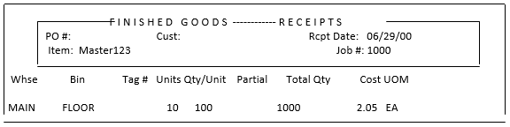

If one of the components were short of making 1000 of the master items, the system would display the screen below, and would prompt “Create receipt with maximum quantity available”.

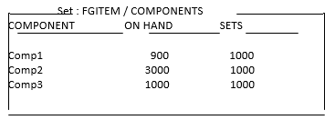

Since there are only 900 on-hand for Comp1, the system would only allow you to enter a receipt for 900 of the master item.

The Set Header (Master123) will show a quantity of 900 on-hand.

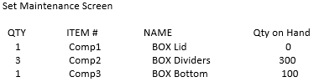

# **Unassembled Sets**

## Overview

By default, all sets are built as Unassembled sets. To change an item to an assembled set go to page two of the Finished Goods file for the set header item. Change “Set Alloc Flag” to Assembled.

Please Note: If the item has quantities on-hand, and you wish to change the set allocation flag, you must do a physical count on the header, and all the components.

When you receive to the set header, it will populate the components of that set.

### Example

Example: The following is the D-1-1 screen. We are entering a receipt for 1000 of the set master item.

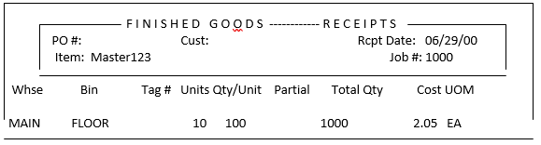

#### After Posting this Receipt

* The Set Header (Master123) will show a quantity of 1000.
* The components of that set will show a quantity equal to the quantity of the set header, times the quantity per set.

In the example below:

* Comp1 and Comp3 will show a quantity on-hand of 1000. (1000 * 1).
* Comp2 will show a quantity of 3000. (3000 * 1)

